July 29th. 2012
Hi
Well, first of all it is a 'Happy Birthday' to Elymie this coming Friday (one year old) and Leonie on Saturday (a little older). See the pictures (and read the letter) for birthday pictures I used five years ago. I still like the pictures.
Last weekend Beijing had the heaviest rainfall for about 60 years. A lot of flooding and about 40 people drowned, though there have been online protests that this figure was much lower than the actual number. The propaganda minister ordered the media to report only on the positive aspects of the flooding!
Another protest is to be held in HK today. This time it is against the introduction of National Education subject in primary schools in September. Many people here regard it as brainwashing. It seems to have been ordered by Beijing and will not do much to help the CE who is already widely believed to be under Beijing's control following the help they gave him in being elected as CE. I am not too happy about it either if the radio reports are accurate. For example, the teaching materials say people should cry in front of the national flag, that the communist party is glorious and that democratic systems around the world are inferior to the mainland system. And to make matters worse, the government did not prepare the subject materials themselves but gave the job to a very staunch pro-communist group to do! Also, remember that many people are refugees or migrants from China (including your grandparents) most of who are none too happy with the mainland system. (Another example which I may have mentioned is that of a lady who used to work at Harbour Plaza - Grace, Leonie you might have met her) whose family were property owners and who fled to HK following the murder of some of them during the cultural revolution (1966-1976). You have heard about the “one country two systems” idea and that applies to ways of thought as well with people here having quite a different political sensibility to people across the border.
This past week we had a #10 typhoon, the highest possible signal and the first since 1999. It started off as a very feeble low pressure area and was not expected to intensity. But then it turned north and headed straight for HK becoming more and more powerful as it did so. It then veered away slightly crossing Macau. It did not seem to be that strong here and the #10 was only raised for a few hours in the middle of the night. But winds in high places (mountains that is!) such as on Lantau Island reached 240 km/h which is 'super typhoon' strength.
But the #10 typhoon I remember in vivid detail was (super) typhoon “Hope” which hit a couple of days before Leonie was born and was the worst for many years. It was terrifying. I remember the water drainage hole on the balcony of the flat at CU became blocked with leaves so water filled up and flowed into the flat. I had to tie a rope to myself and go out to clear the leaves. The wind outside was incredible and I could easily has been blown off the balcony. (The flooding of the flat also showed that the building was not level as all the water flowed to one side of the flat first!) Going to the hospital (Adventist Hospital on HK side) was difficult, with water, trees and debris across all the roads. We made it though. And Leonie knew nothing about it! There are many websites about this typhoon; here are two:
http://en.wikipedia.org/wiki/Typhoon_Hope_(1979)
http://www.weather.gov.hk/informtc/no10/hope/hope.htm
Because of the typhoon this past week there were no swims on Monday and Tuesday. To make up for this I also went for a swim yesterday (Saturday). The water in the pool after the storm was much cooler - about 26⁰C.
I heard on the radio and saw on the Internet that Sally Ride, the first US woman astronaut, died aged only 61. She was a Stanford graduate. Another radio report said that HK women are now the longest living in world (85+). They have taken the place of women in Japan.
Did you see the opening of the Olympics? I didn’t of course as I still do not have a TV. The reports suggest that it was very good. It included a video clip involving the (real!) queen in a skit with James Bond. Quite a different opening from the spectacular but very politically correct opening in Beijing. HK have not started too well. A swimmer was knocked out in a swimming race and HK's best cyclist coming 37th is a road race (but only 40 s behind the winner).
You probably heard about the latest Mitt Romney gaffe, this time at the Olympics. The poor guy only seems to be able to open his mouth in order to put his foot in it! Well this time he made critical comments about the London Olympic while he was actually in London. The British PM was understandably mad and replied that it was much easier to organise an Olympics in the 'middle of nowhere' referring to the winter games in Utah in 2002(?) which Romney was involved in.
In Super Rugby, the Crusaders just lost to the Chiefs (another NZ team) in one of the semi-finals. The final will be in Hamilton next weekend between the Chiefs and a SA team.
That's about it
Cheers
July 29th. 2007
Hi
Well, first of all, its ‘Happy Birthday’ to Leonie for next Saturday. Take your pick of birthday cards! (Actually, I have used these cars before but I still think they are quite good.)

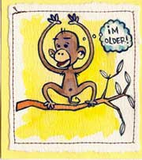
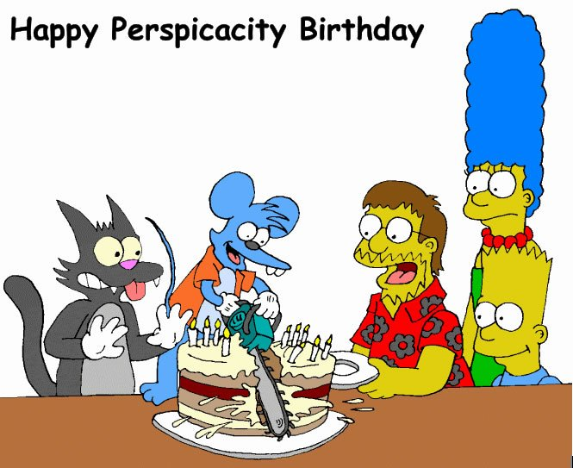

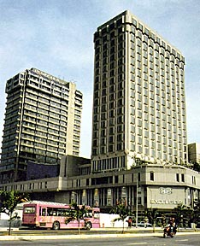
As mentioned the last time I wrote, I was in Singapore for 9 days. I got back to HK two days ago. Left HK on Thursday 18th in the early afternoon, arriving in Singapore shortly after 5 pm. There was a company employee there to take me to the hotel called the Peninsula-Excelsior Hotel, a double-barrelled name, as it is two adjacent old hotels renovated into one. Although it has the name ‘Peninsula’ in it, I was not expecting it to be anything like the HK Peninsula and this was the case, but it was OK. It has two swimming pools but I did not have time to use them. During the trip, the cost to me was exactly nothing!! This included hotel, taxis and meals.
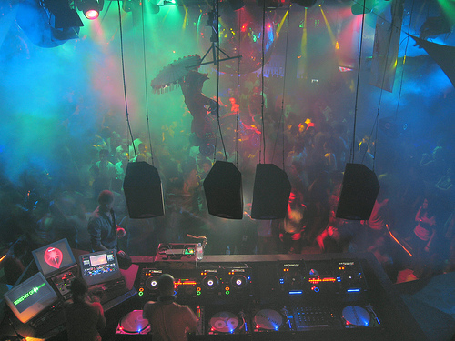
On the first complete day, Friday, I spent the whole day ‘enjoying’ myself in a discotheque, the first time in my life. Let me explain. The re-launch of the book (same book but just a new edition for a revised syllabus) was held in the ‘Ministry of Sound.’ I assumed that this was a Singapore government building but could not figure out why they needed such a ministry. However, as the NZ government has (had?) a ‘Ministry for the America’s Cup’ I supposed anything was possible. Well, instead of being the name of a government department, it is the name of a discotheque! The publisher decided to do something different and have the launch there during the day when the disco is not open for business. During the day, I gave two talks (instead of the expected three) to teachers. Lunch and dinner with some company staff.
The launch was held on a Friday rather than Saturdays (as in previous years) as Singapore now has a 5-day working week and many teachers would not come on a Saturday. Therefore, on Saturday there was nothing to do. I walked around the river area, dodging rain showers and down to the bay and its Merlion (half mermaid, half lion, the name being coined from a fish, which was an old symbol for Singapore and a lion, which a 14th Century ruler mistakenly thought he saw – there have never been any lions in Singapore.). In the evening, I walked the short distance from the hotel back to the bay to watch a National Day parade practice – fireworks, naval boats, helicopters, parachutists, 42 'jellyfish' hot-air balloons, one for each year of independence. Saw on TV that NZ beat Australia 26-12 to take the tri-nations title.
Sunday, was similar. Just walked around a historical park area which was opposite the hotel (and which I visited last year as well). On returning, I looked though a Civil Defence museum, which is part of the Central Fire Station. For a souvenir, I did a small brass rubbing of a 19th Century fire engine.
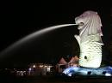
On Monday, I took a taxi to the office. (Singapore taxi drivers can be a very talkative lot if you get them going. On three of the six taxi rides I took, the drivers talked non-stop for the whole 30-minute ride.) At the office, I began the onerous task of fixing up the 'mess' left by the books' editor (now on maternity leave). This took the whole week and I was often working into the night to get things done. As a result of this, the workshop I was supposed to conduct on Thursday was postponed.
Friday was the last day. Spent the day on the index for Book 1. Also, checked in online, which means one only need to arrive at the airport one hour before departure. (I did the same before leaving HK). However, the Singapore Airlines Internet check-in system has problems and it took an hour to get it done, and even then, it would not print the boarding pass. Arrived at the airport bust before 6 pm for the 7 pm flight. On arrival in HK, I just missed the 11 pm shuttle bus, so waited for the midnight bus. Used the hour to look around the new airport Terminal 2 (which I also did on the previous Thursday before leaving). The thing I liked about the HK airport is its simplicity – even an idiot could find his way around. However, Terminal 2 has really complicated things. To start with, just trying to get there from Terminal 1 (where departing passengers arrive) is a nightmare. There is no direct route, and people have to find there way out almost to the bus terminal then do a turn trough a narrow corridor along to a hotel bus park then up stairs again to the terminal! At present, only two airlines use Terminal 2 (and then only got departures and not arrivals) and passengers then take the airport train to gates in Terminal 1.
Yesterday, I had to go to the supermarket. I had a big load of food, as the fridge was empty. I had planned this so that there was no food left to go rotten when I left from HK.
That seems to be it for now.
Cheers

